Product Group: Software
Product: CMSW7400 - @ptitude Analyst
Version: 9MR1

Abstract
This article covers how to change the date format on scheduled reports that are delegated to the transaction server.

Overview
Scheduled reports that are delegated to the transaction server will not use the regional setting of the user creating the scheduled rule.
They will by default be created using the regional setting of the system account on the system running the transaction server service.
This article will cover two ways of changing the reginal setting controlling the date. format.
It is recommended to check with your local IT. Which is the most appropriate to use.

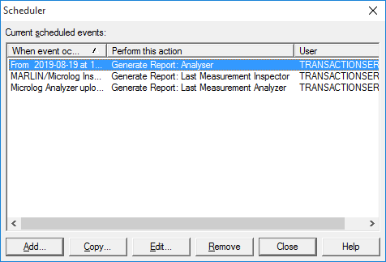
Figure 1 Scheduled Reports Delegated to the Transaction server

Option 1 Change the date and time format of the system user
This will modify the system user running the transaction server service.
The display language, Input language, Format and location will be copied over to the System account. This may affect more programs and systems then the Analyst and the transaction server.

- Log in to a user with the wanted date format on the system running the service.
- Go to Control Panel -> View By: Large/Small Icons ->
Region and Language
- Go to Administrative -> Copy settings
- Check welcome screen and system account.
- Click K.
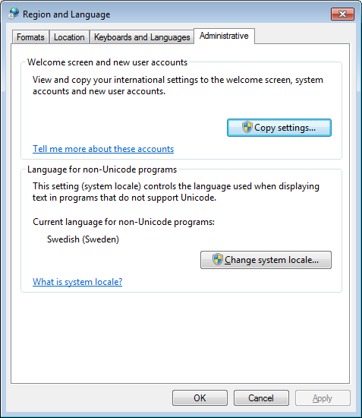

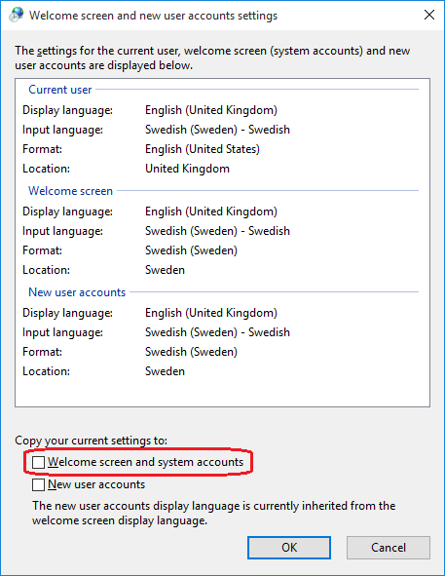
Figure 3 Copy regional setting to system
Figure 2 Region and Language

Option 2 Create a new user with wanted date and time format
This will create a new user and then assign the transaction server service to be run by this user. It is recommended to check with your local IT before creating users.

- On the system running the transaction server service
- Go to Control Panel -> View By: Large/Small icons -> Administrative Tools -> Computer Management
- Then System Tools -> Local users and Groups -> Users
- Right Click and choose New User.
- Fill out appropriate name and password.
It is recommended uncheck User must change password on next logon
and the check Password never expires.
- Click Create and then Close
- Log in to the created user and set the regional setting wanted
- Go to Administrative Tools -> Services
- Find the service for the transaction server.
Default name is SKF @ptitude Transaction Server
- Stop the Service
- Right click take Properties and go to Log On
- Select this account and enter the user created previously.

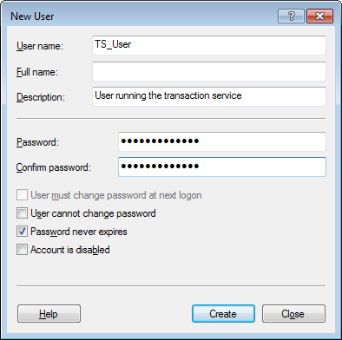
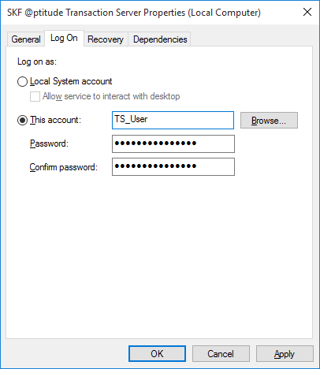
- Click OK and start the service again
Figure 5 New User dialog
Figure 4 Transaction server service properties

