As of the 30th of April everybody will be moved from RDCHome (https://ogc.cmcrdc.com/x/) to RDWeb (https://nlamrd.cmcrdc.com/RDWeb/).
The reason for the switch over is to improved performance, security, and availability
(You will now be able use any browser to connect).

After the 3rd of May you will not be able to logon/access via RDC home login page.

Please follow the 4 Step instructions below to access your RD Web login page.
Do this starting 4th of May 2020 to access your database.

If you experience any issues; please create a ticket at
https://skftechnicalsupport.zendesk.com/hc/en-us/requests/new

Step #1
Go to: https://nlamrd.cmcrdc.com/RDWeb/ “Copy and paste into your browser” or Ctrl+Click

Log in with Domain\User name, meaning rdcnlam\your user name (user bgates as an example below). Then type in your password. Press ‘Sign in’.

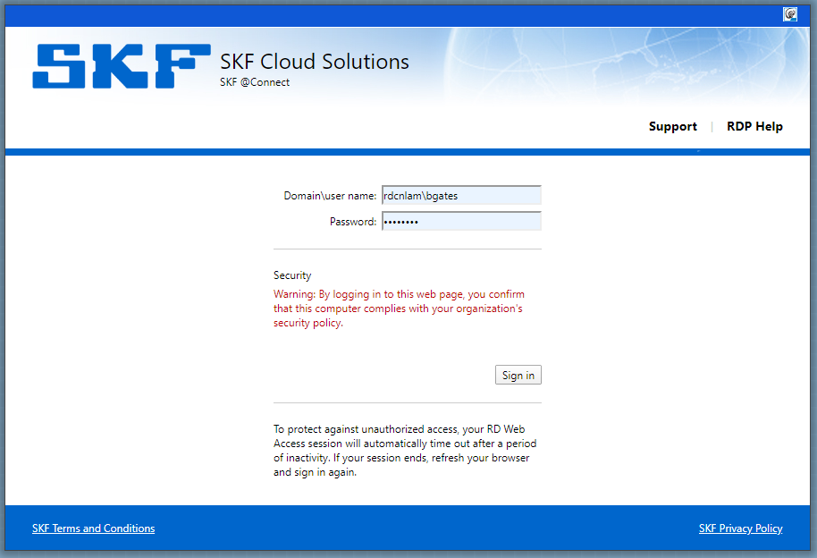

Step #2
Press the database you wish to log on to. All your accesses should be visible in this view, except for Observer which is sorted by version. In this example we use Analyst, press ‘Analyst database’.

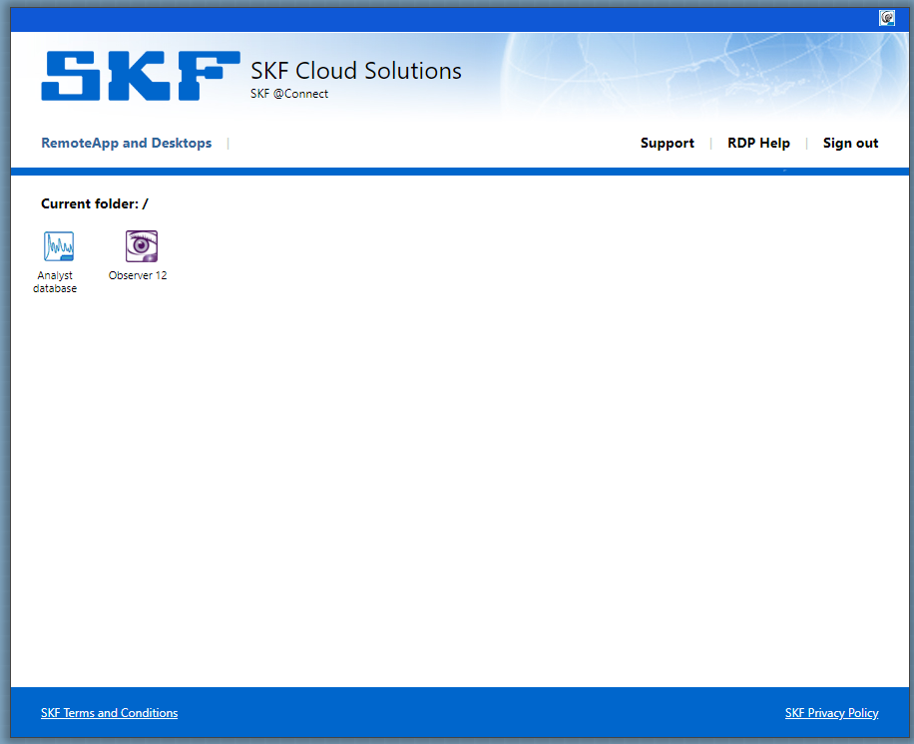

Step #3
After you’ve pressed ‘Analyst database’ the following prompt will show (picture below).
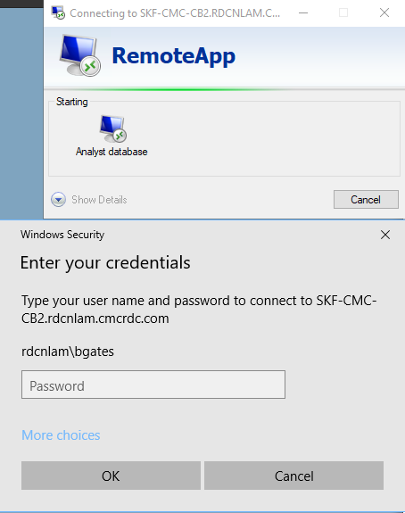

If the default login doesn’t say “rdcnlam\your user name” (typically first letter of given name and surname of the person) then press 'More choices' and ‘Use a different account’.

Next, in the window below type in your User name and your Password:
rdcnlam\your user name “example” Password: Your password, then press OK

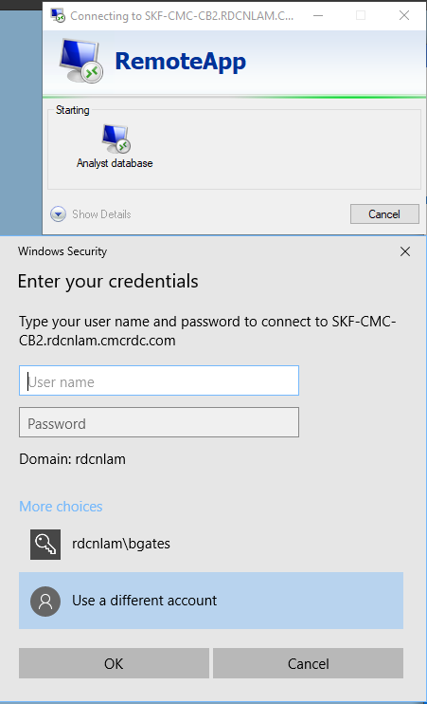

Now you can log onto the database.

Step #4
The next window will look like the picture below. Type in your database User name and Password

“Example”
Name: bgates
Password: Your password

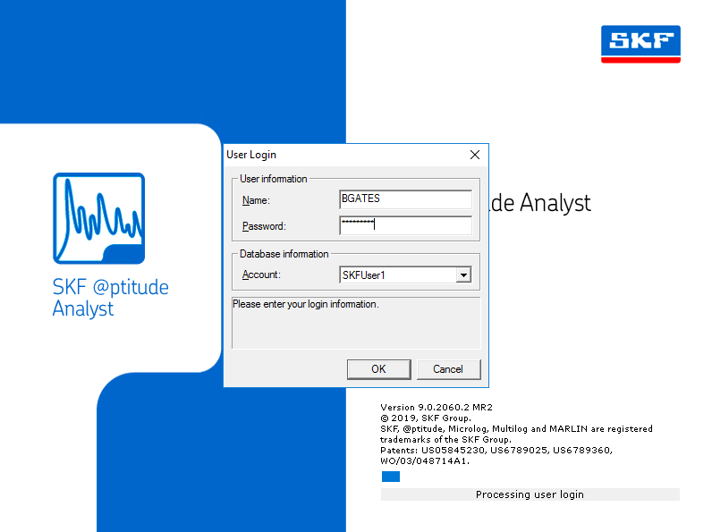

If you experience any issues; please create a ticket at
https://skftechnicalsupport.zendesk.com/hc/en-us/requests/new

Additionally
Login instructions are available on: https://skftechnicalsupport.zendesk.com/hc/en-us/articles/360045529334-Instructions-for-login-to-RDWeb

